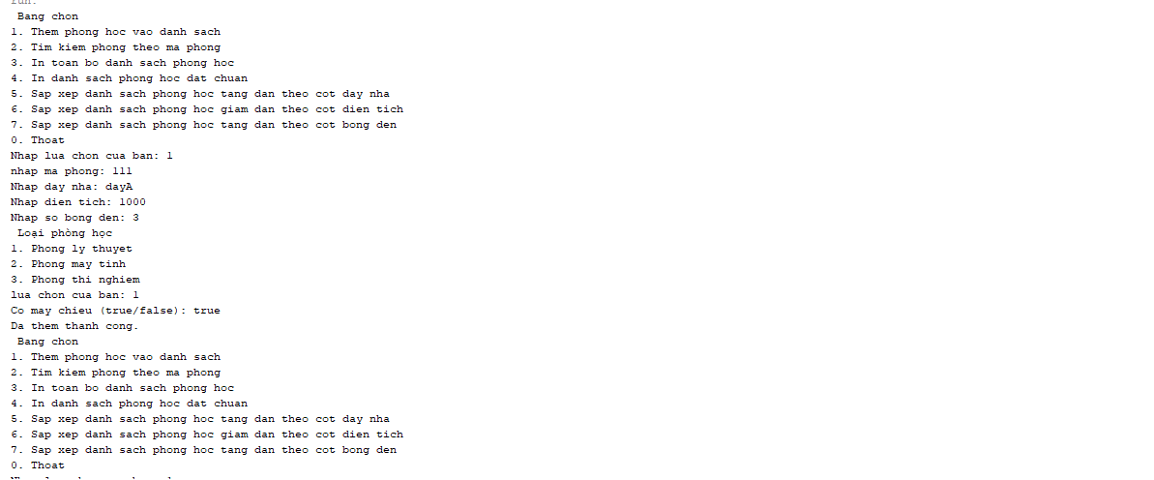
Console

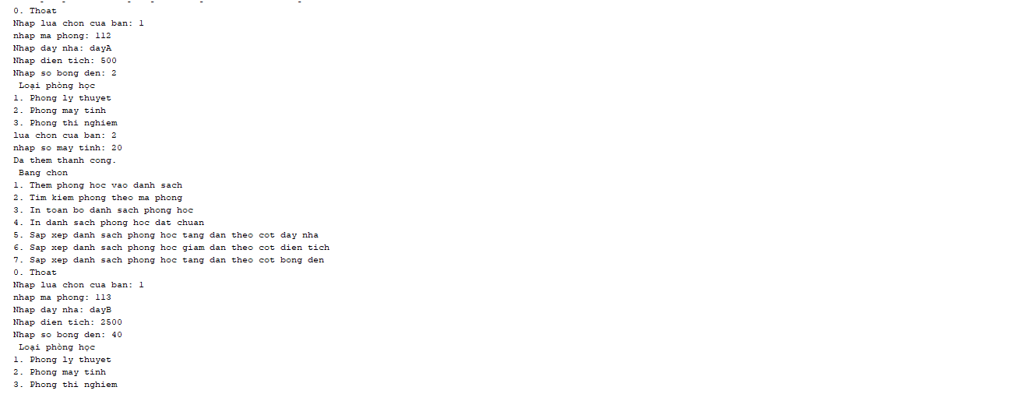

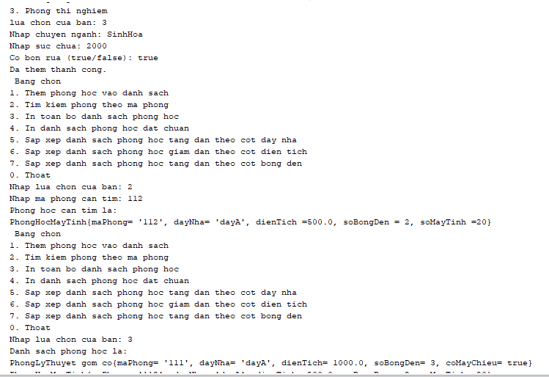
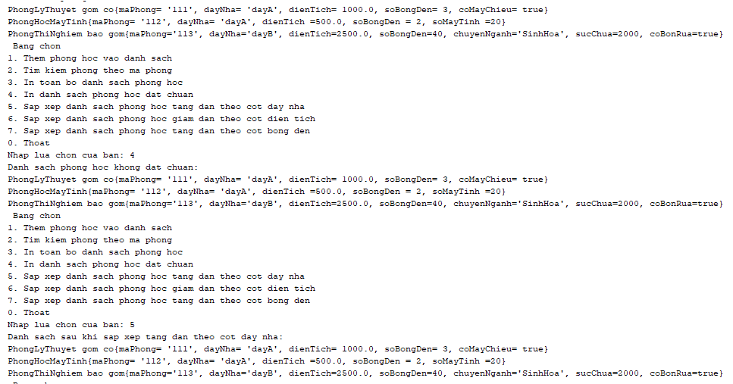
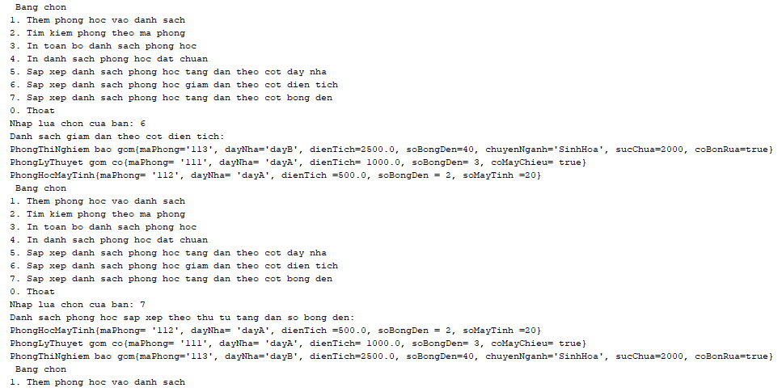
Code PhongHoc:
import java.util.ArrayList;
import java.util.Collections;
import java.util.Comparator;
import java.util.List;
class PhongHoc {
private String maPhong;
private String dayNha;
private double dienTich;
private int soBongDen;
public PhongHoc(String maPhong, String dayNha, double dienTich, int soBongDen) {
this.maPhong = maPhong;
this.dayNha = dayNha;
this.dienTich = dienTich;
this.soBongDen = soBongDen;
}
public String getMaPhong() {
return maPhong;
}
public String getDayNha() {
return dayNha;
}
public double getDienTich() {
return dienTich;
}
public int getSoBongDen() {
return soBongDen;
}
@Override
public String toString() {
return "PhongHoc co{" +
"maPhong= '" + maPhong + '\'' + ", dayNha= '" + dayNha + '\'' + ", dienTich= " + dienTich + ", soBongDen= " + soBongDen +'}';
}
}

Code PhongLyThuyet
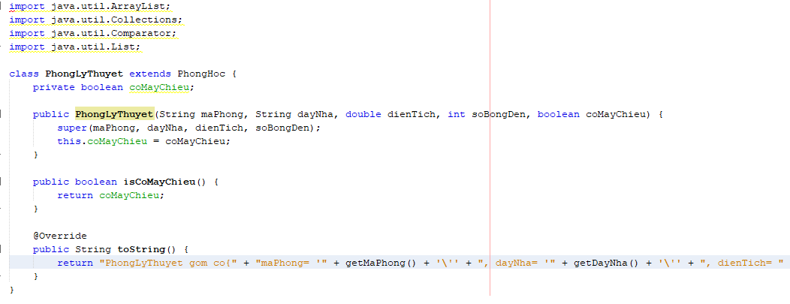
Code PhongMayTinh
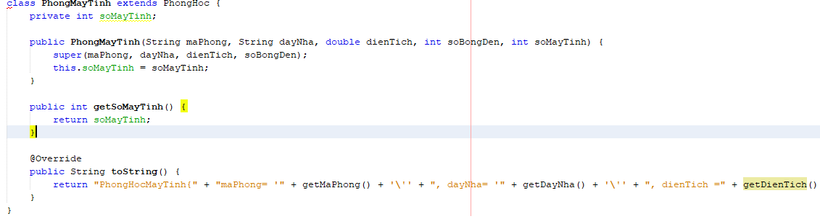

Code PhongThiNghiem
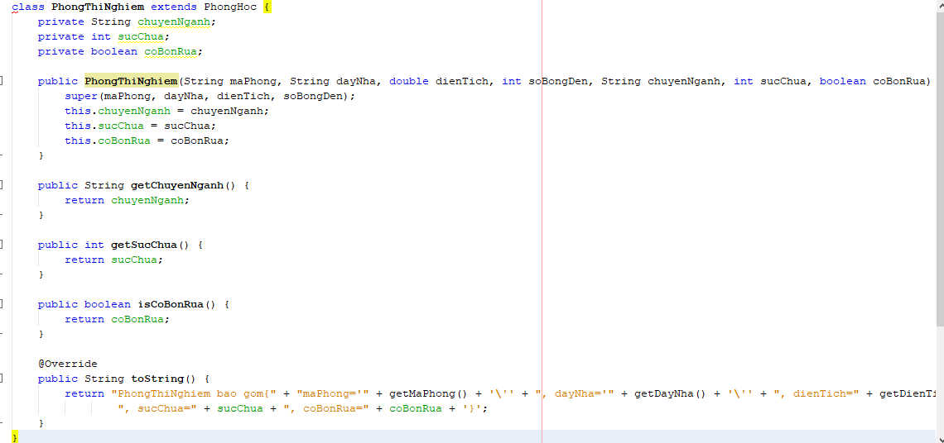

Code QuanliPhongHoc
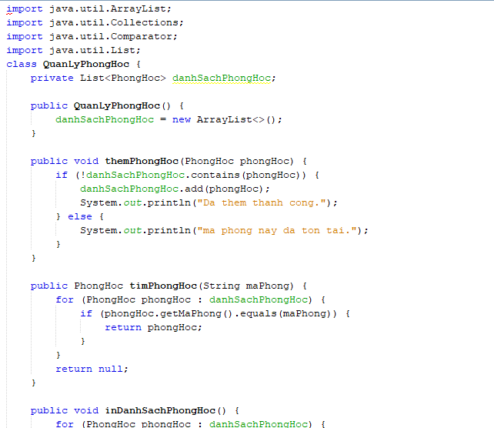

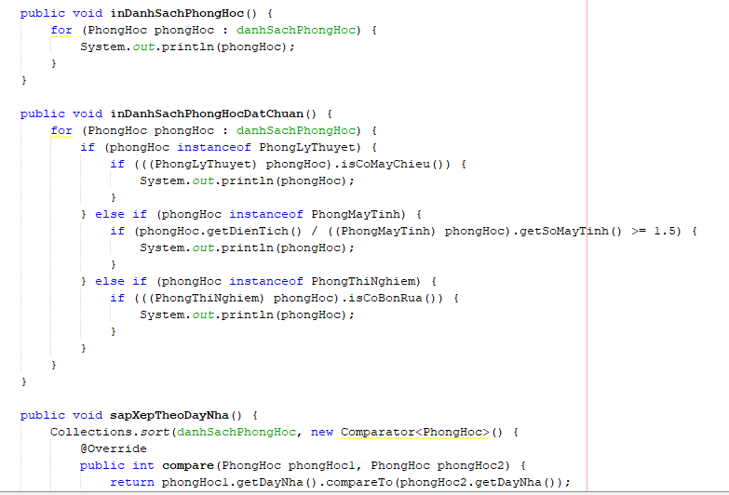
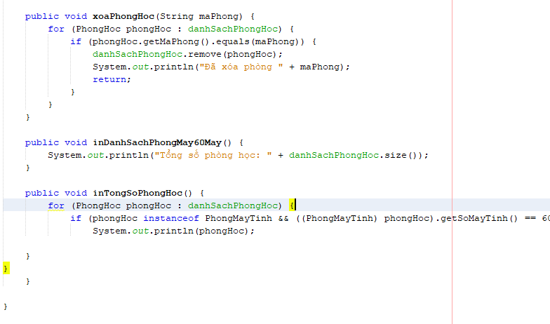

Code Main
